Discussion 8- Kinship in the US
It is often said that kinship is not important in societies such as the United Sates. However, how do our kinship relationships still have significance? Can you think of any sub-cultural groups in the United Sates that tend to live in extended families rather than nuclear families? How do you explain this? What are other forms of social relationships or commitments that, in your opinion, replace kinship ties in America? What about the blended family? 50%-51% of all marriages in the United States end and divorce and 70% of those go on to remarry. What are the dynamics in these families? What about the children of the blended families?

Exercise 8 Let this be fun! The anthropology way!
Exercise 8: "Drawing a kinship chart"

As you know from this chapter, kinship systems are extremely important. They tell you about many essential things in your life such as: whom you can marry, after whom you will inherit, whom you can ask for help and what kind of obligations you may have towards various members of your family and beyond it.
Anthropologists are known for making kinship charts that would exemplify different systems of blood and marriage relations. This week you will get a taste of what it means to make a genealogical chart. Below you will find an example of such a chart for the kinship system preferred in the US. Draw your own chart for at least three generations: you and your sibling, your parents and your grandparents. Use the symbols of reference (father, sister, uncle, etc.) for each person.
Since you will have to use different geometrical figures and marks to show all the different kinds of relation, I suggest that you create your chart in Word and then post it as an attachment. You may also draw it by hand, scan it or take a picture with your phone and attach under Discussions:

Exercise 8 .
Click here to post your kinship chart Exercise 8: "Drawing a kinship chart" This is mandatory!

Yours does not have to be that elaborate, just three generations and you count as one, your parents two and your grandparents three. Some of you that excel at the computer will create masterpiece, others can scan and download crayon diagrams. There isn't a wrong way to do this so do not fret! BUT do it!
(You may need to go back to the module that contained residency patterns and marriage to refresh your memory)
This example down there is really a bit over the hill, I do not need names unless you want to label your kin.
Three generations. If you happen to have more than one mother just go with the one that gave birth to you and you siblings from her.

Example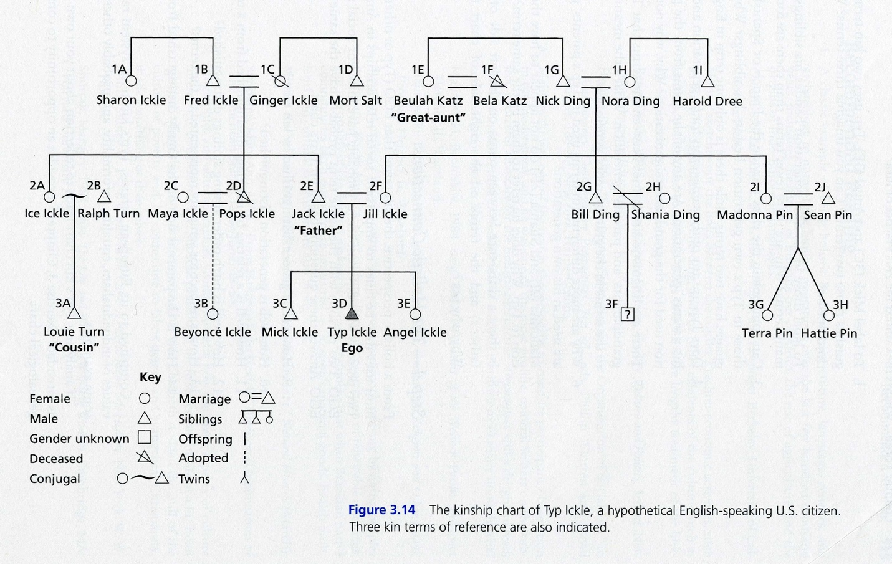

Discussion 9 - supernatural
This is your discussion question for this module:
There are many cultural variations in distinguishing between the natural and the supernatural. Give some examples. Based on the examples that you gave, what is meant by the "supernatural"? What is your definition of supernatural? Is it a cross-culturally valid concept?
Something to ask yourself: When I moved here to this area I was told that you had to believe in ghosts to see them. Have you ever heard this? I do not see them, but I have meet several people that do and had one that I never saw but she was driving my poor dog nuts. What about you?
This is your exercise for this module:
Watch the film on healers from Ghana and comment on it. How are medicine and religion intertwined in the culture presented in th film? Can you give examples of religious beliefs influencing medical realm in the US?

Exercise 9: Film: Healers of Ghana
Film: Healers of Ghana (1993, 58 min.): This film examines the traditional religious and healing practices of the peoples of Techiman, a culturally diverse rural area of Ghana. The focus is on the Bono people, their traditional religious beliefs as manifested through healing practices, and on recent accommodations to Western medical practices. It seems that this is one film that most of you will find interesting. IT isn't so depressing!
Read more about the film in Anthropology Review Database: http://wings.buffalo.edu/ARD/showme.cgi?keycode=150
First go to the film link: https://iris.etsu.edu:3443/login?url=https://fod.infobase.com/PortalPlaylists.aspx?wID=104058&xtid=6135
You may have to use your etsu log in and password to get into the library's film bank. It seems I am locked out now!
Discussion 10
Many social scientists feel that social stratification is an essential part of any society. Someone has to do the dirty work , so to say. Tell me: by using your critical analysis thinking cap if there is or ever could be an utopia society on Earth. Is stratification like the air we breath essential? There are records of hundreds of attempts. Some lasted tens of years, but in the end failed. Why?
I lived in a commune when I was young. It was as close as I think one could come to being in an egalitarian society, but there were people with positions. Someone made the work schedules, cooking and going to the store. Someone took care of the $$ and the recourses. So, I don't know. It was a different time.
Someone had to clean the toilets, right?
Someone has to run things, right? What do you think?
Exercise 10 - "Racism"
Exercise 10: “Social Stratification - Racism”
America isn't the only country with racial problems. Find a website with an article that exemplifies racial problems in a country other than the US or South America. For 10 bonus points post a link of a country that does not have racism of any type.

Discussion 11 - Definition of art
Find a short clip of a dance from another culture and share it with us. Tell us what kind of dance it is. Is it for a rite of passage? A marriage? A death? You get the picture. What are the aesthetic rules governing dancing in America and what are the aesthetic (or other) principles underlying the art of dance in other cultures? What is the cultural significance of dancing?
* One of my favorite discussion topics for this chapter is the art associated with the Upper Paleolithic Period. Your text page 270-271 ( depends on what edition of text you have) contains Altamira in Spain. My favorite is Las-Caux Cave in France. Spend some time on-line at this site and tell me how they painted the ceilings.

Exercise 11
Exercise 11: "Changing canons of beauty"
Have you heard your parents complaining of "kids being pierced everywhere"? Have you had a friend struggling with an eating disorder? Did you get in trouble for having dreadlocks at school?
Well, one root of these situations resides in the ever changing canons of beauty. What is considered beautiful (and therefore good/right/acceptable, etc.) depends on the time and place. What is acceptable in America this season was not in vogue 50 years ago. Miss World or Miss Universe this year might not have been considered beautiful a century ago. And so on.
Your task this week is to find a set of pictures exemplifying different canons of beauty for the human body in different cultures. Put them in a Power Point presentation, in a blog or any other accessible medium. Post the file or link under Discussions: Exercise 11.
Be creative. Don't just pick pictures from fashion pages. Even children stories can exemplify changing ideas of what is pretty. For instance, think about the Cinderella story. In some old versions one sister's foot was too big and the others too small; only Cinderella had the right size. These days most of the stories will picture two ugly sisters with grotesquely big feet while Cinderella's foot is tiny and that's why it fits in the glass slipper. Obviously, there's been a change in what we consider "beautiful" and "right" (in terms of foot size). You will receive 5 bonus points for your effort!
The most beautiful people on Earth: The Wodaabe, my most favorite group of people. Go see for yourself. Go to National Geographic Videos and type in Wodaabe Video give me some feed back. I am sure that some of you are already familiar with these beautiful people of the western sub-Sahara. Maybe you can tell me something I don't know? Use any other search engine you like. Yes it is for 5 bonus points. Just add it into your post for Ex 11

Execise and discussion for this module: number 12
This film contains several chapters content. You will receive 20 points for this film: exercise and discussion for 12. I expect some insightful and meaningful final contributions. See if this changes your view on those beads that so many people have hanging from their car's rear-view mirrors.
This film is shown in more Anthropology and Sociology classes for an array of different chapters content. Let's see what you think. Post this as exercise 12.
Use either one:
You will go to the university link http://libs.etsu.edu/links/kanopy.html
https://etsu.kanopy.com/video/mardi-gras-made-china-0
When it comes up you will type: Mardi Gras: Made in China
into the search bar. It is the first one.
Exercise and discussion: Film: Mardi Gras: Made In China

Discussion 13- globalization: build me your world
Imagine for a moment that you have just been hired by NASA to plan the development of the first human extraterrestrial settlement. They want you to use your knowledge of other societies to build an ideal community, avoiding the problems of modern society. How would you go about the task? For example, what communities or societies that you know about might you choose as models for extraterrestrial settlements? What would be the main values that you would build into your community? How would people be rewarded for the work they performed? How would you maintain order and settle conflicts? What kind of educational system would you propose? Finally, what are the most serious problems in modern society that you would want to avoid?

The last time 14
Well, this is the end , my friends. Tell me your thoughts about this course and if you enjoyed the ride!
I will "peace out" one last time after I grade your tests. For commenting I will give you up to 10 points.

